**Diwali Outfit Ideas| Get Yourself In-Trend Styles**

Nine days of Navratri are over and now your wardrobe needs some serious update before Diwali festivities start. Diwali celebration starts with Dhanteras and ends with the auspicious occasion of Bhai Duj. These days involve get-togethers, puja at home, festive rituals and other festivities. If you are the person who loves to live every moment to the core and want to fashion up every bit of it than your wardrobe need an instant update before you get on board.

**A Long Anarkali**

This Anarkali **salwar suit** with long Anarkali kurta, matching churidar and beautiful Lehariya print dupatta is something you can’t stop thinking about. The color combination and festive perfect detailing of this set making it a must-buy. This **white suit set for women** from belongs to Biba festive collection.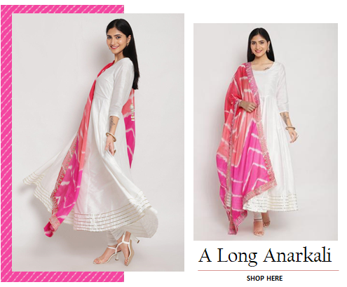

**A Floral Lehenga**

This floral lehenga set in beige color is just perfect to give your look a contemporary make over. You can add some bangles in matching color if you want. This set comes with a sleeveless crop top and light weight dupatta, so that you can move effortlessly flaunting it.

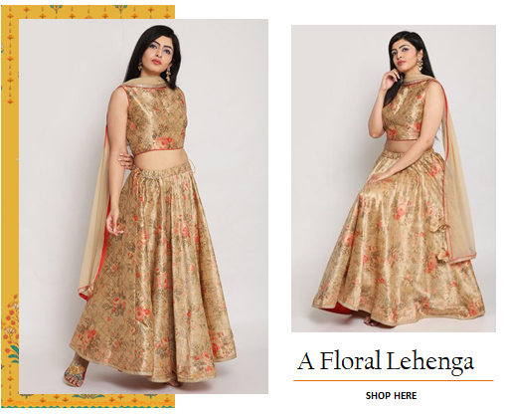

**A Black Sharara**

Sharara suit sets are very much in trend there is no reason you keep them away from your festive wardrobe. Check out this black one. It comes with a short kurta and matching dupatta with Banarasi weaves.

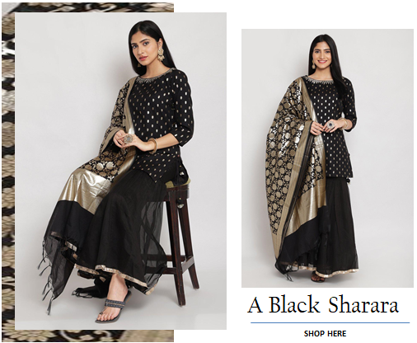

**A Metallic Dress**

This time you can also go for this long dress in metallic print. It will not only give your festive look a contemporary touch but also make it easy to for you to move around and take parts in festivities.

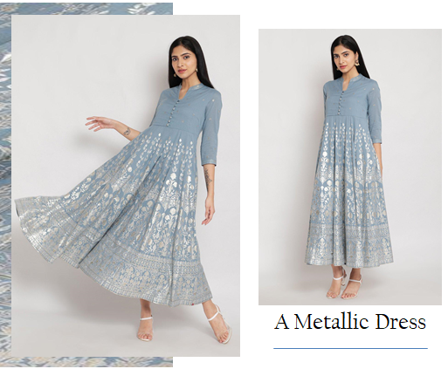

**A Banarasi Suit**

Nothing can replace a Banarasi set when it comes to Indian traditional wear. We have picked a gorgeous Banarasi black suit for women set for your Diwali wardrobe in classy black color with a hint of pink.

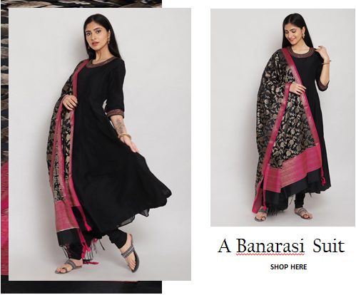

For more outfits idea you explore festive collection online. You can get more choices in different colors and design. Apart from these you can add a green suit, pink suit, and red suit to your festive wardrobe, if you love keeping your looks close to traditional festive colors.

|  |  |  |
| --- | --- | --- |
| <https://www.biba.in/suit-sets> | salwar suit | done |
| https://www.biba.in/suit-sets/black-suit-sets-collection | black suit for women | done |
| https://www.biba.in/suit-sets/green-suit-sets-collection | green suit | done |
| https://www.biba.in/suit-sets/pink-suit-sets-collection | pink suit | done |
| https://www.biba.in/suit-sets/red-suit-sets-collection | red suit for women | done |
| https://www.biba.in/suit-sets/white-suit-sets-collection | white suit for women | done |